Budget

In this section, our project team estimate the cost of each single resource based on the market price and relational documents in Cost Estimating. In Cost Budgeting, our project team show the monthly and overall budget of this project based on the estimation. In Cost Controlling, our team design the baseline to control the actual cost.

(1) Cost Estimating

The resources are listed in the following chart. Our project team use the estimated salary of each job as the estimation cost of the labor for each job [1]. The advertisement fee should be approximately 8% of our whole project budget [2]. There will be 20% of the whole budget used as Reserves to deal with the unexpected situations. After the estimation, the budget of our project should be around AU$65,115,941.76. The detail of the cost estimation of each individual item is shown in the following chart.

(2) Cost Budgeting

Our project team break the total cost of each individual item into the annual individual task. The cost baseline is shown in the following chart.

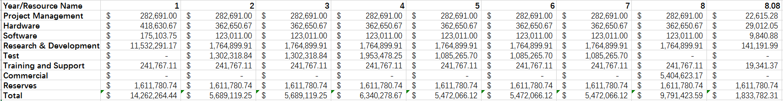

(3) Cost Controlling

The project manager of this project will track the actual cost and the schedule of the task. Based on the data tracked, the project manager should calculate Earned Value Planned Value, Budget at Completion, Estimate at Completion and draw the Earned Value Chart monthly. If Estimate at Completion is 10% more or less than Budget at Completion, the project manager will find the reason for the gap and try to correct the Cost Baseline. After correcting, the project manager will show the new budget to the stakeholders. With the suggestion of the project manager and other stakeholders, the investor should decide whether to add or reduce investment to this project.

In this section, there will be three parts: (1) Cost Estimating (2) Cost Budgeting (3) Cost Controlling.

(1) Cost Estimating

Our group try to estimate the cost of every task in the WBS based on the market price.

(2) Cost Budgeting

Our group will determine the budget of the whole project according to our company’s situation, the future market and our market strategy. Then we will divide the whole budget into individual tasks monthly.

(3) Cost Controlling

Our group will determine some methods to track the cost during the implement of the project. With these methods, our company will try not to run out of budget. For the situations that the project is overbudget, we will also try to determine some methods to fix that problem.

Data

1. Software Engineer / Developer / Programmer Salary

MEDIAN: AU$91,334

2. Project Manager, Information Technology (IT) Salary

MEDIAN: AU$100,812

3. 3D printing service price

<https://www.sculpteo.com/blog/2015/06/25/should-you-buy-a-3d-printer-or-use-a-3d-printing-service-2015-edition/>

<http://3dprint-au.com/3d-printing/pricing/>

4. Physician / Doctor, Cardiologist Salary 4

MEDIAN: AU$120,000

5. Computer Aided Design (CAD) Drafter Salary

MEDIAN: AU$54,114

6. 27-inch iMac with Retina 5K display

3.2GHz Processor 1TB Storage

A$2,799.00

7. advertisement

http://smallbusiness.chron.com/percentage-gross-revenue-should-used-marketing-advertising-55928.html

7 to 10 percent of your total budget should be adequate.

8. Research & Development (R&D) Manager Salary

9. Information Technology (IT) Manager Salary

10. Market Manager Salary

11. Customer Service Officer Salary

12. Marketing Specialist Salary

13. Licensed Software

TurboCAD Deluxe

Visual Studio

14. Reserve

https://pmstudycircle.com/2012/02/contingency-reserve-vs-management-reserve/